3.5 Informed (Heuristic) Search Strategies
This section shows how an informed search strategy, one that uses domain-specific hints about the location of goals, can find solutions more efficiently than an uninformed strategy. The hints come in the form of a heuristic function, denoted h(n):
h(n) = estimated cost of the cheapest path from the state at node n to a goal state.
For example, in route-finding problems, we can estimate the distance from the current state to a goal by computing the straight-line distance on the map between the two points. We study heuristics and where they come from in more detail in Section 3.6.

3.5.1 Greedy best-first search
Greedy best-first search is a form of best-first search that expands first the node with the lowest h(n) value, the node that appears to be closest to the goal, on the grounds that this is likely to lead to a solution quickly. So the evaluation function f(n) = h(n).
Let us see how this works for route-finding problems in Romania; we use the straight-line distance heuristic, which we will call hSLD. If the goal is Bucharest, we need to know the straight-line distance to Bucharest, which are shown in Figure 3.16. For example, hSLD(Arad) = 366. Notice that the values of hSLD cannot be computed from the problem description itself that is, the ACTIONS and RESULT functions. Moreover, it takes a certain amount of world knowledge to know that hSLD is correlated with actual road distances and is, therefore, a useful heuristic.
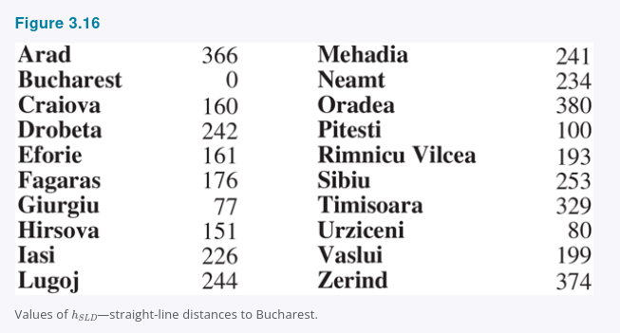
Figure 3.17 shows the progress of a greedy best-first search using hSLD to find a path from Arad to Bucharest. The first node to be expanded from Arad will be Sibiu because the heuristic says it is closer to Bucharest than is either Zerind or Timisoara. The next node to be expanded will be Fagaras because it is now closest according to the heuristic. Fagaras in turn generates Bucharest, which is the goal. For this particular problem, greedy best-first search using hSLD finds a solution without ever expanding a node that is not on the solution path. The solution it found does not have optimal cost, however: the path via Sibiu and Fagaras to Bucharest is 32 miles longer than the path through Rimnicu Vilcea and Pitesti. This is why the algorithm is called “greedy”, on each iteration it tries to get as close to a goal as it can, but greediness can lead to worse results than being careful.
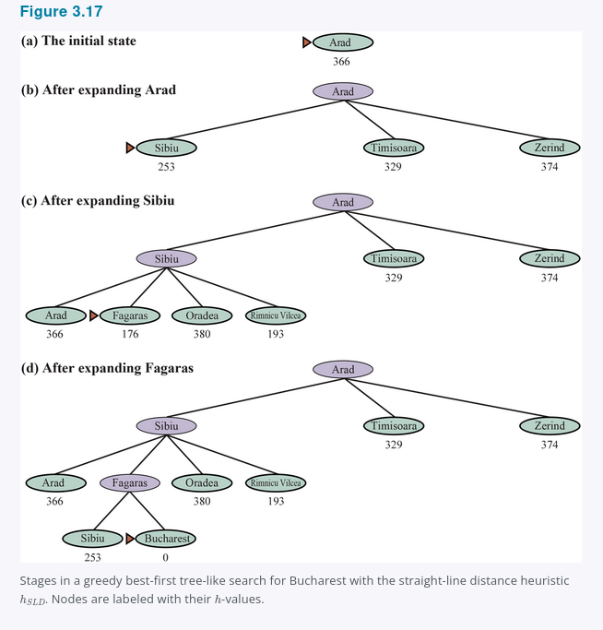

Greedy best-first graph search is complete in finite state spaces, but not in infinite ones. The worst-case time and space complexity is O(|V|). With a good heuristic function, however, the complexity can be reduced substantially, on certain problems reaching O(bm).

3.5.2 A* search
The most common informed search algorithm is A search* pronounced “A-star search”, a best-first search that uses the evaluation function
f(n) = g(n) + h(n)
where g(n) is the path cost from the initial state to node n, and h(n) is the estimated cost of the shortest path from n to a goal state, so we have
f(n) = estimated cost of the best path that continues from n to a goal.
In Figure 3.18, we show the progress of an A* search with the goal of reaching Bucharest. The values of g are computed from the action costs in Figure 3.1, and the values of hSLD are given in Figure 3.16. Notice that Bucharest first appears on the frontier at step e, but it is not selected for expansion and thus not detected as a solution because at f = 450 it is not the lowest-cost node on the frontier, that would be Pitesti, at f = 417. Another way to say this is that there might be a solution through Pitesti whose cost is as low as 417, so the algorithm will not settle for a solution that costs 450. At step f, a different path to Bucharest is now the lowest-cost node, at f = 418, so it is selected and detected as the optimal solution.
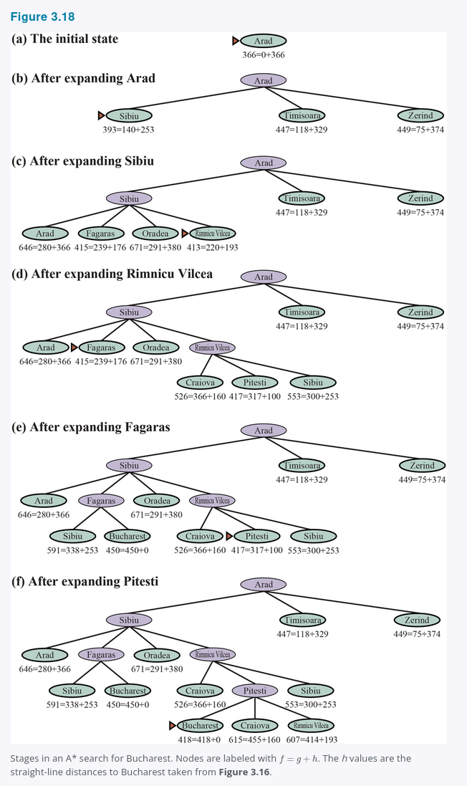

A* search is complete. Whether A* is cost-optimal depends on certain properties of the heuristic. A key property is admissibility: an admissible heuristic is one that never overestimates the cost to reach a goal. An admissible heuristic is therefore optimistic. With an admissible heuristic, A* is cost-optimal, which we can show with a proof by contradiction. Suppose the optimal path has cost C^, but the algorithm returns a path with cost C > C^. Then there must be some node n which is on the optimal path and is unexpanded because if all the nodes on the optimal path had been expanded, then we would have returned that optimal solution. So then, using the notation g^(n) to mean the cost of the optimal path from the start to n, and h^(n) to mean the cost of the optimal path from n to the nearest goal, we have:
f(n) > C* (otherwise n would have been expanded)
f(n) = g(n) + h(n) (by definition)
f(n) = g*(n) + h(n) (because n is on an optimal path)
f(n) <= g*(n) + h*(n) (because of admissibility, h(n) <= h*(n))
f(n) <= C* (by definition, C* = g*(n) + h*(n))
The first and last lines form a contradiction, so the supposition that the algorithm could return a suboptimal path must be wrong, it must be that A* returns only cost-optimal paths.
A slightly stronger property is called consistency. A heuristic h(n) is consistent if, for every node n and every successor n′ of n generated by an action a, we have:
h(n) <= c(n, a, n′) + h(n′).
This is a form of the triangle inequality, which stipulates that a side of a triangle cannot be longer than the sum of the other two sides see Figure 3.19. An example of a consistent heuristic is the straight-line distance hSLD that we used in getting to Bucharest.
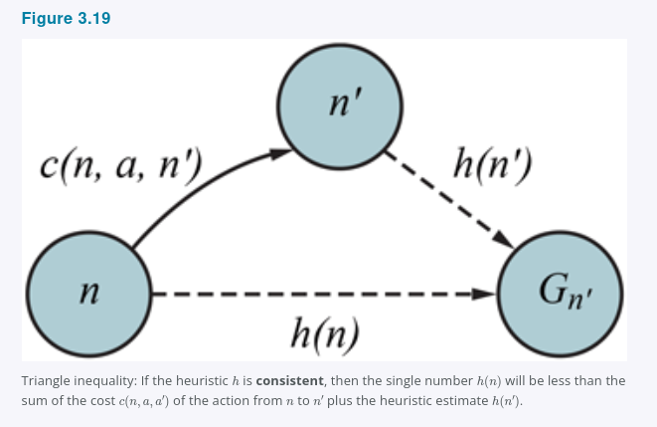

Every consistent heuristic is admissible but not vice versa, so with a consistent heuristic, A* is cost-optimal. In addition, with a consistent heuristic, the first time we reach a state it will be on an optimal path, so we never have to re-add a state to the frontier, and never have to change an entry in reached. But with an inconsistent heuristic, we may end up with multiple paths reaching the same state, and if each new path has a lower path cost than the previous one, then we will end up with multiple nodes for that state in the frontier, costing us both time and space. Because of that, some implementations of A* take care to only enter a state into the frontier once, and if a better path to the state is found, all the successors of the state are updated which requires that nodes have child pointers as well as parent pointers. These complications have led many implementers to avoid inconsistent heuristics, but Felner et al. 2011 argues that the worst effects rarely happen in practice, and one shouldn’t be afraid of inconsistent heuristics.
With an inadmissible heuristic, A* may or may not be cost-optimal. Here are two cases where it is: First, if there is even one cost-optimal path on which h(n) is admissible for all nodes n on the path, then that path will be found, no matter what the heuristic says for states off the path. Second, if the optimal solution has cost C^, and the second-best has cost C2, and if h(n) overestimates some costs, but never by more than C2 - C^, then A* is guaranteed to return cost-optimal solutions.

3.5.3 Search contours
A useful way to visualize a search is to draw contours in the state space, just like the contours in a topographic map. Figure 3.20 shows an example. Inside the contour labeled 400, all nodes have f(n) = g(n) + h(n) <= 400, and so on. Then, because A* expands the frontier node of lowest f-cost, we can see that an A* search fans out from the start node, adding nodes in concentric bands of increasing f-cost.

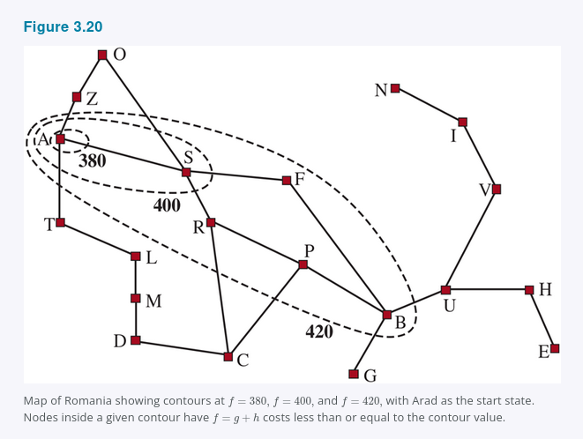

With uniform-cost search, we also have contours, but of g-cost, not g + h. The contours with uniform-cost search will be “circular” around the start state, spreading out equally in all directions with no preference towards the goal. With A* search using a good heuristic, the g + h bands will stretch toward a goal state as in Figure 3.20 and become more narrowly focused around an optimal path.
It should be clear that as you extend a path, the g costs are monotonic: the path cost always increases as you go along a path, because action costs are always positive. Therefore you get concentric contour lines that don’t cross each other, and if you choose to draw the lines fine enough, you can put a line between any two nodes on any path.
But it is not obvious whether the f = g + h cost will monotonically increase. As you extend a path from n to n′, the cost goes from g(n) + h(n) to g(n) + c(n, a, n′) + h(n′). Canceling out the g(n) term, we see that the path’s cost will be monotonically increasing if and only if h(n) <= c(n, a, n′) + h(n′); in other words if and only if the heuristic is consistent. But note that a path might contribute several nodes in a row with the same g(n) + h(n) score; this will happen whenever the decrease in h is exactly equal to the action cost just taken for example, in a grid problem, when n is in the same row as the goal and you take a step towards the goal, g is increased by 1 and h is decreased by 1. If C^* is the cost of the optimal solution path, then we can say the following:
- A* expands all nodes that can be reached from the initial state on a path where every node on the path has f(n) < C^*. We say these are surely expanded nodes.
- A* might then expand some of the nodes right on the “goal contour” where f(n) = C^* before selecting a goal node.
- A* expands no nodes with f(n) > C^*.
We say that A* with a consistent heuristic is optimally efficient in the sense that any algorithm that extends search paths from the initial state, and uses the same heuristic information, must expand all nodes that are surely expanded by A* because any one of them could have been part of an optimal solution. Among the nodes with f(n) = C^*, one algorithm could get lucky and choose the optimal one first while another algorithm is unlucky; we don’t consider this difference in defining optimal efficiency.
A* is efficient because it prunes away search tree nodes that are not necessary for finding an optimal solution. In Figure 3.18(b) we see that Timisoara has f = 447 and Zerind has f = 449. Even though they are children of the root and would be among the first nodes expanded by uniform-cost or breadth-first search, they are never expanded by A* search because the solution with f = 418 is found first. The concept of pruning, eliminating possibilities from consideration without having to examine them, is important for many areas of AI.
That A* search is complete, cost-optimal, and optimally efficient among all such algorithms is rather satisfying. Unfortunately, it does not mean that A* is the answer to all our searching needs. The catch is that for many problems, the number of nodes expanded can be exponential in the length of the solution. For example, consider a version of the vacuum world with a super-powerful vacuum that can clean up any one square at a cost of 1 unit, without even having to visit the square; in that scenario, squares can be cleaned in any order. With N initially dirty squares, there are 2^N states where some subset has been cleaned; all of those states are on an optimal solution path, and hence satisfy f(n) < C^, so all of them would be visited by A.

3.5.4 Satisficing search: Inadmissible heuristics and weighted A*
A* search has many good qualities, but it expands a lot of nodes. We can explore fewer nodes taking less time and space if we are willing to accept solutions that are suboptimal, but are “good enough”, what we call satisficing solutions. If we allow A* search to use an inadmissible heuristic, one that may overestimate, then we risk missing the optimal solution, but the heuristic can potentially be more accurate, thereby reducing the number of nodes expanded. For example, road engineers know the concept of a detour index, which is a multiplier applied to the straight-line distance to account for the typical curvature of roads. A detour index of 1.3 means that if two cities are 10 miles apart in straight-line distance, a good estimate of the best path between them is 13 miles. For most localities, the detour index ranges between 1.2 and 1.6.
We can apply this idea to any problem, not just ones involving roads, with an approach called weighted A search* where we weight the heuristic value more heavily, giving us the evaluation function f(n) = g(n) + W x h(n), for some W > 1.
Figure 3.21 shows a search problem on a grid world. In a, an A* search finds the optimal solution, but has to explore a large portion of the state space to find it. In b, a weighted A* search finds a solution that is slightly costlier, but the search time is much faster. We see that the weighted search focuses the contour of reached states towards a goal. That means that fewer states are explored, but if the optimal path ever strays outside of the weighted search’s contour as it does in this case, then the optimal path will not be found. In general, if the optimal solution costs C^, a weighted A search will find a solution that costs somewhere between C^* and W x C^; but in practice we usually get results much closer to C^ than W x C^*.

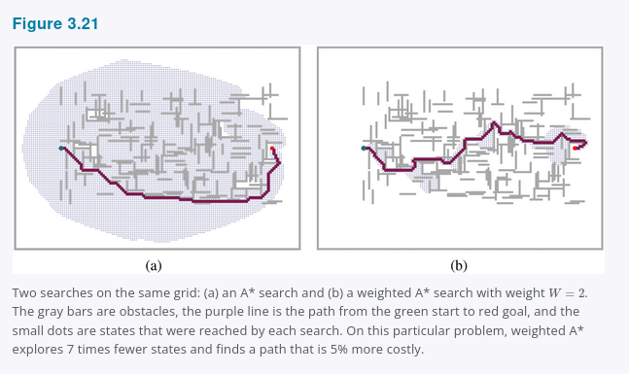

We have considered searches that evaluate states by combining g and h in various ways; weighted A* can be seen as a generalization of the others:
A* search: g(n) + h(n) (W = 1)
Uniform-cost search: g(n) (W = 0)
Greedy best-first search: h(n) (W = infinity)
Weighted A* search: g(n) + W x h(n) (1 < W < infinity)
You could call weighted A* “somewhat-greedy search”: like greedy best-first search, it focuses the search towards a goal; on the other hand, it won’t ignore the path cost completely, and will suspend a path that is making little progress at great cost.
There are a variety of suboptimal search algorithms, which can be characterized by the criteria for what counts as “good enough.” In bounded suboptimal search, we look for a solution that is guaranteed to be within a constant factor W of the optimal cost. Weighted A* provides this guarantee. In bounded-cost search, we look for a solution whose cost is less than some constant C. And in unbounded-cost search, we accept a solution of any cost, as long as we can find it quickly.
An example of an unbounded-cost search algorithm is speedy search, which is a version of greedy best-first search that uses as a heuristic the estimated number of actions required to reach a goal, regardless of the cost of those actions. Thus, for problems where all actions have the same cost it is the same as greedy best-first search, but when actions have different costs, it tends to lead the search to find a solution quickly, even if it might have a high cost.

3.5.5 Memory-bounded search
The main issue with A* is its use of memory. In this section we’ll cover some implementation tricks that save space, and then some entirely new algorithms that take better advantage of the available space.
Memory is split between the frontier and the reached states. In our implementation of best-first search, a state that is on the frontier is stored in two places: as a node in the frontier so we can decide what to expand next and as an entry in the table of reached states so we know if we have visited the state before. For many problems such as exploring a grid, this duplication is not a concern, because the size of frontier is much smaller than reached, so duplicating the states in the frontier requires a comparatively trivial amount of memory. But some implementations keep a state in only one of the two places, saving a bit of space at the cost of complicating and perhaps slowing down the algorithm.
Another possibility is to remove states from reached when we can prove that they are no longer needed. For some problems, we can use the separation property Figure 3.6, along with the prohibition of U-turn actions, to ensure that all actions either move outwards from the frontier or onto another frontier state. In that case, we need only check the frontier for redundant paths, and we can eliminate the reached table.
For other problems, we can keep reference counts of the number of times a state has been reached, and remove it from the reached table when there are no more ways to reach the state. For example, on a grid world where each state can be reached only from its four neighbors, once we have reached a state four times, we can remove it from the table.
Now let’s consider new algorithms that are designed to conserve memory usage.
Beam search limits the size of the frontier. The easiest approach is to keep only the k nodes with the best f-scores, discarding any other expanded nodes. This of course makes the search incomplete and suboptimal, but we can choose k to make good use of available memory, and the algorithm executes fast because it expands fewer nodes. For many problems it can find good near-optimal solutions. You can think of uniform-cost or A* search as spreading out everywhere in concentric contours, and think of beam search as exploring only a focused portion of those contours, the portion that contains the k best candidates.
An alternative version of beam search doesn’t keep a strict limit on the size of the frontier but instead keeps every node whose f-score is within δ of the best f-score. That way, when there are a few strong-scoring nodes only a few will be kept, but if there are no strong nodes then more will be kept until a strong one emerges.
Iterative-deepening A search* IDA* is to A* what iterative-deepening search is to depth-first: IDA* gives us the benefits of A* without the requirement to keep all reached states in memory, at a cost of visiting some states multiple times. It is a very important and commonly used algorithm for problems that do not fit in memory.
In standard iterative deepening the cutoff is the depth, which is increased by one each iteration. In IDA* the cutoff is the f-cost g + h; at each iteration, the cutoff value is the smallest f-cost of any node that exceeded the cutoff on the previous iteration. In other words, each iteration exhaustively searches an f-contour, finds a node just beyond that contour, and uses that node’s f-cost as the next contour. For problems like the 8-puzzle where each path’s f-cost is an integer, this works very well, resulting in steady progress towards the goal each iteration. If the optimal solution has cost C^, then there can be no more than C^ iterations for example, no more than 31 iterations on the hardest 8-puzzle problems. But for a problem where every node has a different f-cost, each new contour might contain only one new node, and the number of iterations could be equal to the number of states.
Recursive best-first search RBFS Figure 3.22 attempts to mimic the operation of standard best-first search, but using only linear space. RBFS resembles a recursive depth-first search, but rather than continuing indefinitely down the current path, it uses the f_limit variable to keep track of the f-value of the best alternative path available from any ancestor of the current node. If the current node exceeds this limit, the recursion unwinds back to the alternative path. As the recursion unwinds, RBFS replaces the f-value of each node along the path with a backed-up value, the best f-value of its children. In this way, RBFS remembers the f-value of the best leaf in the forgotten subtree and can therefore decide whether it’s worth reexpanding the subtree at some later time. Figure 3.23 shows how RBFS reaches Bucharest.

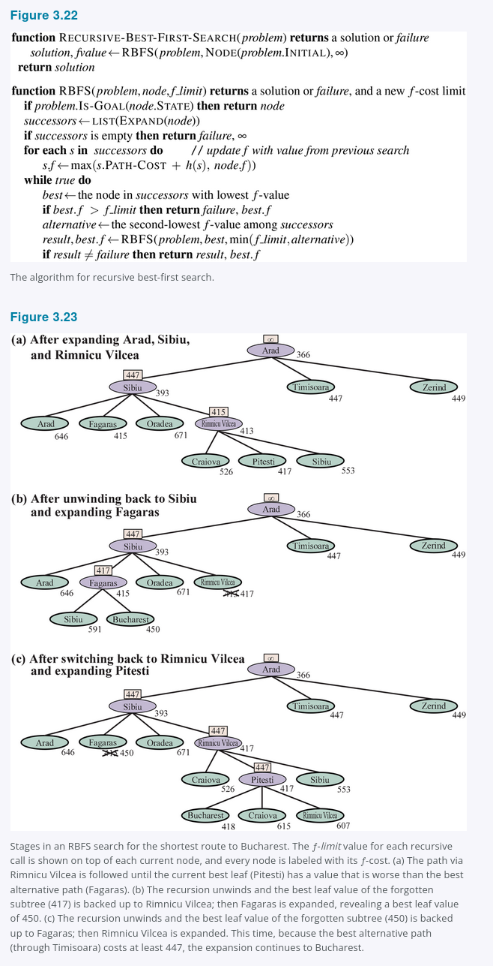

RBFS is somewhat more efficient than IDA*, but still suffers from excessive node regeneration. In the example in Figure 3.23, RBFS follows the path via Rimnicu Vilcea, then “changes its mind” and tries Fagaras, and then changes its mind back again. These mind changes occur because every time the current best path is extended, its f-value is likely to increase, h is usually less optimistic for nodes closer to a goal. When this happens, the second-best path might become the best path, so the search has to backtrack to follow it. Each mind change corresponds to an iteration of IDA* and could require many reexpansions of forgotten nodes to recreate the best path and extend it one more node.
RBFS is optimal if the heuristic function h(n) is admissible. Its space complexity is linear in the depth of the deepest optimal solution, but its time complexity is rather difficult to characterize: it depends both on the accuracy of the heuristic function and on how often the best path changes as nodes are expanded. It expands nodes in order of increasing f-score, even if f is nonmonotonic.
IDA* and RBFS suffer from using too little memory. Between iterations, IDA* retains only a single number: the current f-cost limit. RBFS retains more information in memory, but it uses only linear space: even if more memory were available, RBFS has no way to make use of it. Because they forget most of what they have done, both algorithms may end up reexploring the same states many times over.
It seems sensible, therefore, to determine how much memory we have available, and allow an algorithm to use all of it. Two algorithms that do this are MA* memory-bounded A* and SMA* simplified MA*. SMA* is, well, simpler, so we will describe it. SMA* proceeds just like A*, expanding the best leaf until memory is full. At this point, it cannot add a new node to the search tree without dropping an old one. SMA* always drops the worst leaf node, the one with the highest f-value. Like RBFS, SMA* then backs up the value of the forgotten node to its parent. In this way, the ancestor of a forgotten subtree knows the quality of the best path in that subtree. With this information, SMA* regenerates the subtree only when all other paths have been shown to look worse than the path it has forgotten. Another way of saying this is that if all the descendants of a node n are forgotten, then we will not know which way to go from n, but we will still have an idea of how worthwhile it is to go anywhere from n.
The complete algorithm is described in the online code repository accompanying this book. There is one subtlety worth mentioning. We said that SMA* expands the best leaf and deletes the worst leaf. What if all the leaf nodes have the same f-value? To avoid selecting the same node for deletion and expansion, SMA* expands the newest best leaf and deletes the oldest worst leaf. These coincide when there is only one leaf, but in that case, the current search tree must be a single path from root to leaf that fills all of memory. If the leaf is not a goal node, then even if it is on an optimal solution path, that solution is not reachable with the available memory. Therefore, the node can be discarded exactly as if it had no successors.
SMA* is complete if there is any reachable solution, that is, if d, the depth of the shallowest goal node, is less than the memory size expressed in nodes. It is optimal if any optimal solution is reachable; otherwise, it returns the best reachable solution. In practical terms, SMA* is a fairly robust choice for finding optimal solutions, particularly when the state space is a graph, action costs are not uniform, and node generation is expensive compared to the overhead of maintaining the frontier and the reached set.
On very hard problems, however, it will often be the case that SMA* is forced to switch back and forth continually among many candidate solution paths, only a small subset of which can fit in memory. This resembles the problem of thrashing in disk paging systems. Then the extra time required for repeated regeneration of the same nodes means that problems that would be practically solvable by A*, given unlimited memory, become intractable for SMA*. That is to say, memory limitations can make a problem intractable from the point of view of computation time. Although no current theory explains the tradeoff between time and memory, it seems that this is an inescapable problem. The only way out is to drop the optimality requirement.

3.5.6 Bidirectional heuristic search
With bidirectional best-first search we could also try using f(n) = g(n) + h(n), but unfortunately there is no guarantee that this would lead to an optimal-cost solution, nor that it would be optimally efficient, even with an admissible heuristic. With bidirectional search, it turns out that it is not individual nodes but rather pairs of nodes one from each frontier that can be proved to be surely expanded, so any proof of efficiency will have to consider pairs of nodes Eckerle et al., 2017.
We’ll start with some new notation. We use fF(n) = gF(n) + hF(n) for nodes going in the forward direction with the initial state as root and fB(n) = gB(n) + hB(n) for nodes in the backward direction with a goal state as root. Although both forward and backward searches are solving the same problem, they have different evaluation functions because, for example, the heuristics are different depending on whether you are striving for the goal or for the initial state. We’ll assume admissible heuristics.
Consider a forward path from the initial state to a node m and a backward path from the goal to a node n. We can define a lower bound on the cost of a solution that follows the path from the initial state to m, then somehow gets to n, then follows the path to the goal as
lb(m, n) = max(gF(m) + gB(n), fF(m), fB(n))
In other words, the cost of such a path must be at least as large as the sum of the path costs of the two parts because the remaining connection between them must have nonnegative cost, and the cost must also be at least as much as the estimated f cost of either part because the heuristic estimates are optimistic. Given that, the theorem is that for any pair of nodes m, n with lb(m, n) less than the optimal cost C^*, we must expand either m or n, because the path that goes through both of them is a potential optimal solution. The difficulty is that we don’t know for sure which node is best to expand, and therefore no bidirectional search algorithm can be guaranteed to be optimally efficient, any algorithm might expand up to twice the minimum number of nodes if it always chooses the wrong member of a pair to expand first. Some bidirectional heuristic search algorithms explicitly manage a queue of (m, n) pairs, but we will stick with bidirectional best-first search Figure 3.14, which has two frontier priority queues, and give it an evaluation function that mimics the lb criteria:
f2(n) = max(2g(n), g(n) + h(n))
The node to expand next will be the one that minimizes this f2 value; the node can come from either frontier. This f2 function guarantees that we will never expand a node from either frontier with g(n) > C^/2. We say the two halves of the search “meet in the middle” in the sense that when the two frontiers touch, no node inside of either frontier has a path cost greater than the bound C^/2. Figure 3.24 works through an example bidirectional search.
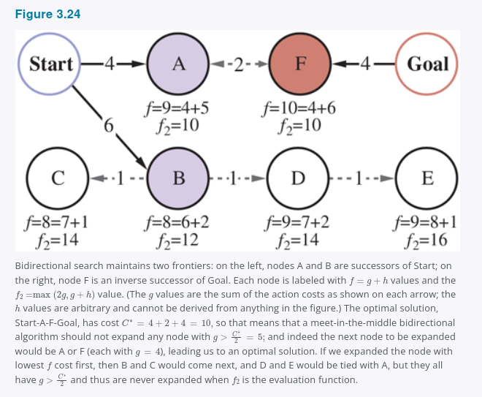

We have described an approach where the hF heuristic estimates the distance to the goal or, when the problem has multiple goal states, the distance to the closest goal and hB estimates the distance to the start. This is called a front-to-end search. An alternative, called front-to-front search, attempts to estimate the distance to the other frontier. Clearly, if a frontier has millions of nodes, it would be inefficient to apply the heuristic function to every one of them and take the minimum. But it can work to sample a few nodes from the frontier. In certain specific problem domains it is possible to summarize the frontier, for example, in a grid search problem, we can incrementally compute a bounding box of the frontier, and use as a heuristic the distance to the bounding box.
Bidirectional search is sometimes more efficient than unidirectional search, sometimes not. In general, if we have a very good heuristic, then A* search produces search contours that are focused on the goal, and adding bidirectional search does not help much. With an average heuristic, bidirectional search that meets in the middle tends to expand fewer nodes and is preferred. In the worst case of a poor heuristic, the search is no longer focused on the goal, and bidirectional search has the same asymptotic complexity as A*. Bidirectional search with the f2 evaluation function and an admissible heuristic h is complete and optimal.

3.6 Heuristic Functions
In this section, we look at how the accuracy of a heuristic affects search performance, and also consider how heuristics can be invented. As our main example we’ll return to the 8-puzzle. As mentioned in Section 3.2, the object of the puzzle is to slide the tiles horizontally or vertically into the empty space until the configuration matches the goal configuration (Figure 3.25).

Figure 3.25
A typical instance of the 8-puzzle. The shortest solution is 26 actions long.
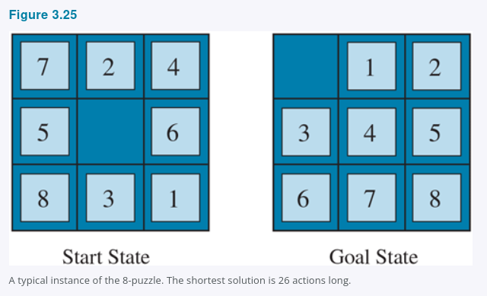

There are 9!/2 = 181,400 reachable states in an 8-puzzle, so a search could easily keep them all in memory. But for the 15-puzzle, there are 16!/2 states, over 10 trillion, so to search that space we will need the help of a good admissible heuristic function. There is a long history of such heuristics for the 15-puzzle; here are two commonly used candidates:
- h1 = the number of misplaced tiles blank not included. For Figure 3.25, all eight tiles are out of position, so the start state has h1 = 8. h1 is an admissible heuristic because any tile that is out of place will require at least one move to get it to the right place.
- h2 = the sum of the distances of the tiles from their goal positions. Because tiles cannot move along diagonals, the distance is the sum of the horizontal and vertical distances, sometimes called the city-block distance or Manhattan distance. h2 is also admissible because all any move can do is move one tile one step closer to the goal. Tiles 1 to 8 in the start state of Figure 3.25 give a Manhattan distance of
h2 = 3 + 1 + 2 + 2 + 2 + 3 + 3 + 2 = 18.
As expected, neither of these overestimates the true solution cost, which is 26.

3.6.1 The effect of heuristic accuracy on performance
One way to characterize the quality of a heuristic is the effective branching factor b^. If the total number of nodes generated by A for a particular problem is N and the solution depth is d, then b^* is the branching factor that a uniform tree of depth d would have to have in order to contain N + 1 nodes. Thus,
N + 1 = 1 + b* + (b*)^2 + ... + (b*)^d.
For example, if A* finds a solution at depth 5 using 52 nodes, then the effective branching factor is 1.92. The effective branching factor can vary across problem instances, but usually for a specific domain such as 8-puzzles it is fairly constant across all nontrivial problem instances. Therefore, experimental measurements of b^* on a small set of problems can provide a good guide to the heuristic’s overall usefulness. A well-designed heuristic would have a value of b^* close to 1, allowing fairly large problems to be solved at reasonable computational cost.
Korf and Reid 1998 argue that a better way to characterize the effect of A* pruning with a given heuristic h is that it reduces the effective depth by a constant kh compared to the true depth. This means that the total search cost is O(b^(d - kh)) compared to O(b^d) for an uninformed search. Their experiments on Rubik’s Cube and n-puzzle problems show that this formula gives accurate predictions for total search cost for sampled problem instances across a wide range of solution lengths, at least for solution lengths larger than kh.
For Figure 3.26 we generated random 8-puzzle problems and solved them with an uninformed breadth-first search and with A* search using both h1 and h2, reporting the average number of nodes generated and the corresponding effective branching factor for each search strategy and for each solution length. The results suggest that h2 is better than h1, and both are better than no heuristic at all.
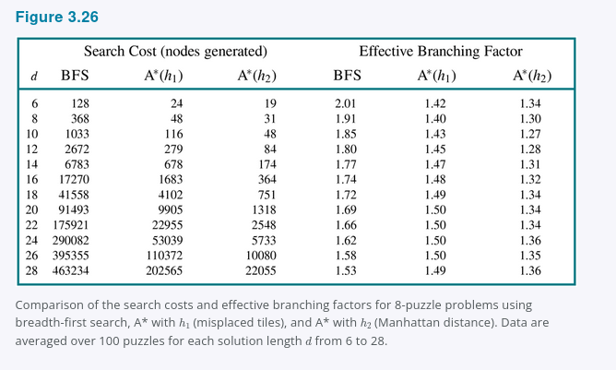

One might ask whether h2 is always better than h1. The answer is “Essentially, yes.” It is easy to see from the definitions of the two heuristics that for any node n, h2(n) >= h1(n). We thus say that h2 dominates h1. Domination translates directly into efficiency: A* using h2 will never expand more nodes than A* using h1 except in the case of breaking ties unluckily. The argument is simple. Recall the observation in Section 3.5 Informed (Heuristic) Search Strategies that every node with f(n) < C^* will surely be expanded. This is the same as saying that every node with h(n) < C^* - g(n) is surely expanded when h is consistent. But because h2 is at least as big as h1 for all nodes, every node that is surely expanded by A* search with h2 is also surely expanded with h1, and h1 might cause other nodes to be expanded as well. Hence, it is generally better to use a heuristic function with higher values, provided it is consistent and that the computation time for the heuristic is not too long.

3.6.2 Generating heuristics from relaxed problems
We have seen that both h1 misplaced tiles and h2 Manhattan distance are fairly good heuristics for the 8-puzzle and that h2 is better. How might one have come up with h2? Is it possible for a computer to invent such a heuristic mechanically?
h1 and h2 are estimates of the remaining path length for the 8-puzzle, but they are also perfectly accurate path lengths for simplified versions of the puzzle. If the rules of the puzzle were changed so that a tile could move anywhere instead of just to the adjacent empty square, then h1 would give the exact length of the shortest solution. Similarly, if a tile could move one square in any direction, even onto an occupied square, then h2 would give the exact length of the shortest solution. A problem with fewer restrictions on the actions is called a relaxed problem. The state-space graph of the relaxed problem is a supergraph of the original state space because the removal of restrictions creates added edges in the graph.
Because the relaxed problem adds edges to the state-space graph, any optimal solution in the original problem is, by definition, also a solution in the relaxed problem; but the relaxed problem may have better solutions if the added edges provide shortcuts. Hence, the cost of an optimal solution to a relaxed problem is an admissible heuristic for the original problem. Furthermore, because the derived heuristic is an exact cost for the relaxed problem, it must obey the triangle inequality and is therefore consistent Section 3.5 Informed (Heuristic) Search Strategies.
If a problem definition is written down in a formal language, it is possible to construct relaxed problems automatically. For example, if the 8-puzzle actions are described as
A tile can move from square X to square Y if
X is adjacent to Y and Y is blank,
we can generate three relaxed problems by removing one or both of the conditions:
a. A tile can move from square X to square Y if X is adjacent to Y.
b. A tile can move from square X to square Y if Y is blank.
c. A tile can move from square X to square Y.
From a, we can derive h2 Manhattan distance. The reasoning is that h2 would be the proper score if we moved each tile in turn to its destination. The heuristic derived from b is discussed in Exercise 3.GASC. From c, we can derive h1 misplaced tiles because it would be the proper score if tiles could move to their intended destination in one action. Notice that it is crucial that the relaxed problems generated by this technique can be solved essentially without search, because the relaxed rules allow the problem to be decomposed into eight independent subproblems. If the relaxed problem is hard to solve, then the values of the corresponding heuristic will be expensive to obtain.
A program called Absolver can generate heuristics automatically from problem definitions, using the “relaxed problem” method and various other techniques Prieditis, 1993. Absolver generated a new heuristic for the 8-puzzle that was better than any preexisting heuristic and found the first useful heuristic for the famous Rubik’s Cube puzzle.
If a collection of admissible heuristics h1 ... hm is available for a problem and none of them is clearly better than the others, which should we choose? As it turns out, we can have the best of all worlds, by defining
h(n) = max {h1(n), ..., hk(n)}.
This composite heuristic picks whichever function is most accurate on the node in question. Because the hi components are admissible, h is admissible and if hi are all consistent, h is consistent. Furthermore, h dominates all of its component heuristics. The only drawback is that h(n) takes longer to compute. If that is an issue, an alternative is to randomly select one of the heuristics at each evaluation, or use a machine learning algorithm to predict which heuristic will be best. Doing this can result in a heuristic that is inconsistent even if every hi is consistent, but in practice it usually leads to faster problem solving.

3.6.3 Generating heuristics from subproblems: Pattern databases
Admissible heuristics can also be derived from the solution cost of a subproblem of a given problem. For example, Figure 3.27 shows a subproblem of the 8-puzzle instance in Figure 3.25. The subproblem involves getting tiles 1, 2, 3, 4, and the blank into their correct positions. Clearly, the cost of the optimal solution of this subproblem is a lower bound on the cost of the complete problem. It turns out to be more accurate than Manhattan distance in some cases.
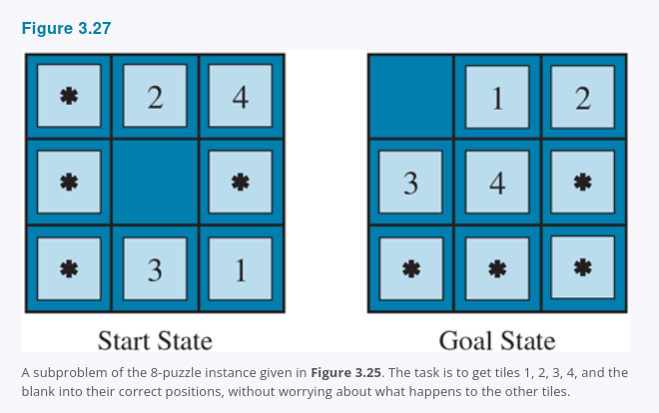

The idea behind pattern databases is to store these exact solution costs for every possible subproblem instance, in our example, every possible configuration of the four tiles and the blank. There will be 9 x 8 x 7 x 6 x 5 = 15,120 patterns in the database. The identities of the other four tiles are irrelevant for the purposes of solving the subproblem, but moves of those tiles do count toward the solution cost of the subproblem. Then we compute an admissible heuristic hDB for each state encountered during a search simply by looking up the corresponding subproblem configuration in the database. The database itself is constructed by searching back from the goal and recording the cost of each new pattern encountered; the expense of this search is amortized over subsequent problem instances, and so makes sense if we expect to be asked to solve many problems.
The choice of tiles 1-2-3-4 to go with the blank is fairly arbitrary; we could also construct databases for 5-6-7-8, for 2-4-6-8, and so on. Each database yields an admissible heuristic, and these heuristics can be combined, as explained earlier, by taking the maximum value. A combined heuristic of this kind is much more accurate than the Manhattan distance; the number of nodes generated when solving random 15-puzzles can be reduced by a factor of 1000. However, with each additional database there are diminishing returns and increased memory and computation costs.
One might wonder whether the heuristics obtained from the 1-2-3-4 database and the 5-6-7-8 could be added, since the two subproblems seem not to overlap. Would this still give an admissible heuristic? The answer is no, because the solutions of the 1-2-3-4 subproblem and the 5-6-7-8 subproblem for a given state will almost certainly share some moves, it is unlikely that 1-2-3-4 can be moved into place without touching 5-6-7-8, and vice versa. But what if we don’t count those moves, what if we don’t abstract the other tiles to stars, but rather make them disappear? That is, we record not the total cost of solving the 1-2-3-4 subproblem, but just the number of moves involving 1-2-3-4. Then the sum of the two costs is still a lower bound on the cost of solving the entire problem. This is the idea behind disjoint pattern databases. With such databases, it is possible to solve random 15-puzzles in a few milliseconds, the number of nodes generated is reduced by a factor of 10,000 compared with the use of Manhattan distance. For 24-puzzles, a speedup of roughly a factor of a million can be obtained. Disjoint pattern databases work for sliding-tile puzzles because the problem can be divided up in such a way that each move affects only one subproblem, because only one tile is moved at a time.

3.6.4 Generating heuristics with landmarks
There are online services that host maps with tens of millions of vertices and find cost-optimal driving directions in milliseconds Figure 3.28. How can they do that, when the best search algorithms we have considered so far are about a million times slower? There are many tricks, but the most important one is precomputation of some optimal path costs. Although the precomputation can be time-consuming, it need only be done once, and then can be amortized over billions of user search requests.

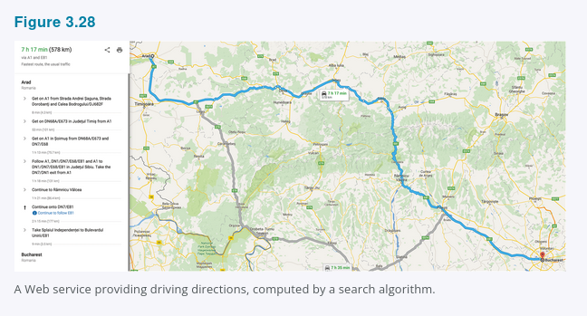

We could generate a perfect heuristic by precomputing and storing the cost of the optimal path between every pair of vertices. That would take O(|V|^2) space, and O(|E|^3) time, practical for graphs with 10 thousand vertices, but not 10 million.
A better approach is to choose a few perhaps 10 or 20 landmark points from the vertices. Then for each landmark L and for each other vertex v in the graph, we compute and store C^(v, L), the exact cost of the optimal path from v to L. We also need C^(L, v); on an undirected graph this is the same as C^(v, L); on a directed graph e.g., with one-way streets, we need to compute this separately. Given the stored C^ tables, we can easily create an efficient although inadmissible heuristic: the minimum, over all landmarks, of the cost of getting from the current node to the landmark, and then to the goal:
hL(n) = min over L in Landmarks C*(n, L) + C*(L, goal)
If the optimal path happens to go through a landmark, this heuristic will be exact; if not it is inadmissible, it overestimates the cost to the goal. In an A* search, if you have exact heuristics, then once you reach a node that is on an optimal path, every node you expand from then on will be on an optimal path. Think of the contour lines as following along this optimal path. The search will trace along the optimal path, on each iteration adding an action with cost c to get to a result state whose h-value will be c less, meaning that the total f = g + h score will remain constant at C^* all along the path.
Some route-finding algorithms save even more time by adding shortcuts, artificial edges in the graph that define an optimal multi-action path. For example, if there were shortcuts predefined between all the 100 biggest cities in the U.S., and we were trying to navigate from the Berkeley campus in California to NYU in New York, we could take the shortcut between Sacramento and Manhattan and cover 90% of the path in one action.
hL(n) is efficient but not admissible. But with a bit more care, we can come up with a heuristic that is both efficient and admissible:
hDH(n) = max over L in Landmarks |C*(n, L) - C*(goal, L)|
This is called a differential heuristic because of the subtraction. Think of this with a landmark that is somewhere out beyond the goal. If the goal happens to be on the optimal path from n to the landmark, then this is saying “consider the entire path from n to L, then subtract off the last part of that path, from goal to L, giving us the exact cost of the path from n to goal.” To the extent that the goal is a bit off of the optimal path to the landmark, the heuristic will be inexact, but still admissible. Landmarks that are not out beyond the goal will not be useful; a landmark that is exactly halfway between n and goal will give hDH = 0, which is not helpful.
There are several ways to pick landmark points. Selecting points at random is fast, but we get better results if we take care to spread the landmarks out so they are not too close to each other. A greedy approach is to pick a first landmark at random, then find the point that is furthest from that, and add it to the set of landmarks, and continue, at each iteration adding the point that maximizes the distance to the nearest landmark. If you have logs of past search requests by your users, then you can pick landmarks that are frequently requested in searches. For the differential heuristic it is good if the landmarks are spread around the perimeter of the graph. Thus, a good technique is to find the centroid of the graph, arrange k pie-shaped wedges around the centroid, and in each wedge select the vertex that is farthest from the center.
Landmarks work especially well in route-finding problems because of the way roads are laid out in the world: a lot of traffic actually wants to travel between landmarks, so civil engineers build the widest and fastest roads along these routes; landmark search makes it easier to recover these routes.

3.6.5 Learning to search better
We have presented several fixed search strategies, breadth-first, A*, and so on, that have been carefully designed and programmed by computer scientists. Could an agent learn how to search better? The answer is yes, and the method rests on an important concept called the metalevel state space. Each state in a metalevel state space captures the internal computational state of a program that is searching in an ordinary state space such as the map of Romania. To keep the two concepts separate, we call the map of Romania an object-level state space. For example, the internal state of the A* algorithm consists of the current search tree. Each action in the metalevel state space is a computation step that alters the internal state; for example, each computation step in A* expands a leaf node and adds its successors to the tree. Thus, Figure 3.18, which shows a sequence of larger and larger search trees, can be seen as depicting a path in the metalevel state space where each state on the path is an object-level search tree.
Now, the path in Figure 3.18 has five steps, including one step, the expansion of Fagaras, that is not especially helpful. For harder problems, there will be many such missteps, and a metalevel learning algorithm can learn from these experiences to avoid exploring unpromising subtrees. The techniques used for this kind of learning are described in Chapter 22. The goal of learning is to minimize the total cost of problem solving, trading off computational expense and path cost.

3.6.6 Learning heuristics from experience
We have seen that one way to invent a heuristic is to devise a relaxed problem for which an optimal solution can be found easily. An alternative is to learn from experience. “Experience” here means solving lots of 8-puzzles, for instance. Each optimal solution to an 8-puzzle problem provides an example goal, path pair. From these examples, a learning algorithm can be used to construct a function h that can with luck approximate the true path cost for other states that arise during search. Most of these approaches learn an imperfect approximation to the heuristic function, and thus risk inadmissibility. This leads to an inevitable tradeoff between learning time, search run time, and solution cost. Techniques for machine learning are demonstrated in Chapter 19. The reinforcement learning methods described in Chapter 22 are also applicable to search.
Some machine learning techniques work better when supplied with features of a state that are relevant to predicting the state’s heuristic value, rather than with just the raw state description. For example, the feature “number of misplaced tiles” might be helpful in predicting the actual distance of an 8-puzzle state from the goal. Let’s call this feature x1(n). We could take 100 randomly generated 8-puzzle configurations and gather statistics on their actual solution costs. We might find that when x1(n) is 5, the average solution cost is around 14, and so on. Of course, we can use multiple features. A second feature x2(n) might be “number of pairs of adjacent tiles that are not adjacent in the goal state.” How should x1(n) and x2(n) be combined to predict h(n)? A common approach is to use a linear combination:
h(n) = c1x1(n) + c2x2(n).
The constants c1 and c2 are adjusted to give the best fit to the actual data across the randomly generated configurations. One expects both c1 and c2 to be positive because misplaced tiles and incorrect adjacent pairs make the problem harder to solve. Notice that this heuristic satisfies the condition h(n) = 0 for goal states, but it is not necessarily admissible or consistent.

Summary
This chapter has introduced search algorithms that an agent can use to select action sequences in a wide variety of environments, as long as they are episodic, single-agent, fully observable, deterministic, static, discrete, and completely known. There are tradeoffs to be made between the amount of time the search takes, the amount of memory available, and the quality of the solution. We can be more efficient if we have domain-dependent knowledge in the form of a heuristic function that estimates how far a given state is from the goal, or if we precompute partial solutions involving patterns or landmarks.
- Before an agent can start searching, a well-defined problem must be formulated.
- A problem consists of five parts: the initial state, a set of actions, a transition model describing the results of those actions, a set of goal states, and an action cost function.
- The environment of the problem is represented by a state space graph. A path through the state space, a sequence of actions from the initial state to a goal state, is a solution.
- Search algorithms generally treat states and actions as atomic, without any internal structure, although we introduced features of states when it came time to do learning.
- Search algorithms are judged on the basis of completeness, cost optimality, time complexity, and space complexity.
- Uninformed search methods have access only to the problem definition. Algorithms build a search tree in an attempt to find a solution. Algorithms differ based on which node they expand first:
  - Best-first search selects nodes for expansion using an evaluation function.
  - Breadth-first search expands the shallowest nodes first; it is complete, optimal for unit action costs, but has exponential space complexity.
  - Uniform-cost search expands the node with lowest path cost, g(n), and is optimal for general action costs.
  - Depth-first search expands the deepest unexpanded node first. It is neither complete nor optimal, but has linear space complexity. Depth-limited search adds a depth bound.
  - Iterative deepening search calls depth-first search with increasing depth limits until a goal is found. It is complete when full cycle checking is done, optimal for unit action costs, has time complexity comparable to breadth-first search, and has linear space complexity.
  - Bidirectional search expands two frontiers, one around the initial state and one around the goal, stopping when the two frontiers meet.
- Informed search methods have access to a heuristic function h(n) that estimates the cost of a solution from n. They may have access to additional information such as pattern databases with solution costs.
  - Greedy best-first search expands nodes with minimal h(n). It is not optimal but is often efficient.
  - A search* expands nodes with minimal f(n) = g(n) + h(n). A* is complete and optimal, provided that h(n) is admissible. The space complexity of A* is still an issue for many problems.
  - Bidirectional A search* is sometimes more efficient than A* itself.
  - IDA* iterative deepening A* search is an iterative deepening version of A*, and thus addresses the space complexity issue.
  - RBFS recursive best-first search and SMA* simplified memory-bounded A* are robust, optimal search algorithms that use limited amounts of memory; given enough time, they can solve problems for which A* runs out of memory.
  - Beam search puts a limit on the size of the frontier; that makes it incomplete and suboptimal, but it often finds reasonably good solutions and runs faster than complete searches.
  - Weighted A* search focuses the search towards a goal, expanding fewer nodes, but sacrificing optimality.
- The performance of heuristic search algorithms depends on the quality of the heuristic function. One can sometimes construct good heuristics by relaxing the problem definition, by storing precomputed solution costs for subproblems in a pattern database, by defining landmarks, or by learning from experience with the problem class.

Bibliographical and Historical Notes
The topic of state-space search originated in the early years of AI. Newell and Simon’s work on the Logic Theorist 1957 and GPS 1961 led to the establishment of search algorithms as the primary tool for 1960s AI researchers and to the establishment of problem solving as the canonical AI task. Work in operations research by Richard Bellman 1957 showed the importance of additive path costs in simplifying optimization algorithms. The text by Nils Nilsson 1971 established the area on a solid theoretical footing.
The 8-puzzle is a smaller cousin of the 15-puzzle, whose history is recounted at length by Slocum and Sonneveld 2006. In 1880, the 15-puzzle attracted broad attention from the public and mathematicians Johnson and Story, 1879; Tait, 1880. The editors of the American Journal of Mathematics stated, “The ‘15’ puzzle for the last few weeks has been prominently before the American public, and may safely be said to have engaged the attention of nine out of ten persons of both sexes and all ages and conditions of the community,” while the Weekly News-Democrat of Emporia, Kansas wrote on March 12, 1880 that “It has become literally an epidemic all over the country.”
The famous American game designer Sam Loyd falsely claimed to have invented the 15 puzzle Loyd, 1959; actually it was invented by Noyes Chapman, a postmaster in Canastota, New York, in the mid-1870s although a generic patent covering sliding blocks was granted to Ernest Kinsey in 1878. Ratner and Warmuth 1986 showed that the general n x n version of the 15-puzzle belongs to the class of NP-complete problems.
Rubik’s Cube was of course invented in 1974 by Ernő Rubik, who also discovered an algorithm for finding good, but not optimal solutions. Korf 1997 found optimal solutions for some random problem instances using pattern databases and IDA* search. Rokicki et al. 2014 proved that any instance can be solved in 26 moves if you consider a 180° twist to be two moves; 20 if it counts as one. The proof consumed 35 CPU years of computation; it does not lead immediately to an efficient algorithm. Agostinelli et al. 2019 used reinforcement learning, deep learning networks, and Monte Carlo tree search to learn a much more efficient solver for Rubik’s cube. It is not guaranteed to find a cost-optimal solution, but does so about 60% of the time, and typical solutions times are less than a second.
Each of the real-world search problems listed in the chapter has been the subject of a good deal of research effort. Methods for selecting optimal airline flights remain proprietary for the most part, but Carl de Marcken has shown by a reduction to Diophantine decision problems that airline ticket pricing and restrictions have become so convoluted that the problem of selecting an optimal flight is formally undecidable Robinson, 2002. The traveling salesperson problem TSP is a standard combinatorial problem in theoretical computer science Lawler et al., 1992. Karp 1972 proved the TSP decision problem to be NP-hard, but effective heuristic approximation methods were developed Lin and Kernighan, 1973. Arora 1998 devised a fully polynomial approximation scheme for Euclidean TSPs. VLSI layout methods are surveyed by LaPaugh 2010, and many layout optimization papers appear in VLSI journals. Robotic navigation is discussed in Chapter 26. Automatic assembly sequencing was first demonstrated by Freddy Michie, 1972; a comprehensive review is given by Bahubalendruni and Biswal, 2016.
Uninformed search algorithms are a central topic of computer science Cormen et al., 2009 and operations research Dreyfus, 1969. Breadth-first search was formulated for solving mazes by Moore 1959. The method of dynamic programming Bellman, 1957; Bellman and Dreyfus, 1962, which systematically records solutions for all subproblems of increasing lengths, can be seen as a form of breadth-first search.
Dijkstra’s algorithm in the form it is usually presented in Dijkstra, 1959 is applicable to explicit finite graphs. Nilsson 1971 introduced a version of Dijkstra’s algorithm that he called uniform-cost search because the algorithm “spreads out along contours of equal path cost” that allows for implicitly defined, infinite graphs. Nilsson’s work also introduced the idea of closed and open lists, and the term “graph search.” The name Best-First-Search was introduced in the Handbook of AI Barr and Feigenbaum, 1981. The Floyd-Warshall Floyd, 1962 and Bellman-Ford Bellman, 1958; Ford, 1956 algorithms allow negative step costs as long as there are no negative cycles.
A version of iterative deepening designed to make efficient use of the chess clock was first used by Slate and Atkin 1977 in the Chess 4.5 game-playing program. Martelli’s algorithm B 1977 also includes an iterative deepening aspect. The iterative deepening technique was introduced by Bertram Raphael 1976 and came to the fore in work by Korf 1985a.
The use of heuristic information in problem solving appears in an early paper by Simon and Newell 1958, but the phrase “heuristic search” and the use of heuristic functions that estimate the distance to the goal came somewhat later Newell and Ernst, 1965; Lin, 1965. Doran and Michie 1966 conducted extensive experimental studies of heuristic search. Although they analyzed path length and “penetrance” the ratio of path length to the total number of nodes examined so far, they appear to have ignored the information provided by the path cost g(n). The A* algorithm, incorporating the current path cost into heuristic search, was developed by Hart, Nilsson, and Raphael 1968. Dechter and Pearl 1985 studied the conditions under which A* is optimally efficient in number of nodes expanded.
The original A* paper Hart et al., 1968 introduced the consistency condition on heuristic functions. The monotone condition was introduced by Pohl 1977 as a simpler replacement, but Pearl 1984 showed that the two were equivalent.
Pohl 1977 pioneered the study of the relationship between the error in heuristic functions and the time complexity of A*. Basic results were obtained for tree-like search with unit action costs and a single goal state Pohl, 1977; Gaschnig, 1979; Huyn et al., 1980; Pearl, 1984 and with multiple goal states Dinh et al., 2007. Korf and Reid 1998 showed how to predict the exact number of nodes expanded not just an asymptotic approximation on a variety of actual problem domains. The “effective branching factor” was proposed by Nilsson 1971 as an empirical measure of efficiency. For graph search, Helmert and Röger 2008 noted that several well-known problems contained exponentially many nodes on optimal-cost solution paths, implying exponential time complexity for A*.
There are many variations on the A* algorithm. Pohl 1970 introduced weighted A* search, and later a dynamic version 1973, where the weight changes over the depth of the tree. Ebendt and Drechsler 2009 synthesize the results and examine some applications. Hatem and Ruml 2014 show a simplified and improved version of weighted A* that is easier to implement. Wilt and Ruml 2014 introduce speedy search as an alternative to greedy search that focuses on minimizing search time, and Wilt and Ruml 2016 show that the best heuristics for satisficing search are different from the ones for optimal search. Burns et al. 2012 give some implementation tricks for writing fast search code, and Felner 2018 considers how the implementation changes when using an early goal test.
Pohl 1971 introduced bidirectional search. Holte et al. 2016 describe the version of bidirectional search that is guaranteed to meet in the middle, making it more widely applicable. Eckerle et al. 2017 describe the set of surely expanded pairs of nodes, and show that no bidirectional search can be optimally efficient. The NBS algorithm Chen et al., 2017 makes explicit use of a queue of pairs of nodes.
A combination of bidirectional A* and known landmarks was used to efficiently find driving routes for Microsoft’s online map service Goldberg et al., 2006. After caching a set of paths between landmarks, the algorithm can find an optimal-cost path between any pair of points in a 24-million-point graph of the United States, searching less than 0.1% of the graph. Korf 1987 shows how to use subgoals, macro-operators, and abstraction to achieve remarkable speedups over previous techniques. Delling et al. 2009 describe how to use bidirectional search, landmarks, hierarchical structure, and other tricks to find driving routes. Anderson et al. 2008 describe a related technique, called coarse-to-fine search, which can be thought of as defining landmarks at various hierarchical levels of abstraction. Korf 1987 describes conditions under which coarse-to-fine search provides an exponential speedup. Knoblock 1991 provides experimental results and analysis to quantify the advantages of hierarchical search.
A* and other state-space search algorithms are closely related to the branch-and-bound techniques that are widely used in operations research Lawler and Wood, 1966; Rayward-Smith et al., 1996. Kumar and Kanal 1988 attempt a “grand unification” of heuristic search, dynamic programming, and branch-and-bound techniques under the name of CDP, the “composite decision process.”
Because most computers in the 1960s had only a few thousand words of main memory, memory-bounded heuristic search was an early research topic. The Graph Traverser Doran and Michie, 1966, one of the earliest search programs, commits to an action after searching best-first up to the memory limit. IDA* Korf, 1985b was the first widely used length-optimal, memory-bounded heuristic search algorithm, and a large number of variants have been developed. An analysis of the efficiency of IDA* and of its difficulties with real-valued heuristics appears in Patrick et al. 1992.
The original version of RBFS Korf, 1993 is actually somewhat more complicated than the algorithm shown in Figure 3.22, which is actually closer to an independently developed algorithm called iterative expansion or IE Russell, 1992. RBFS uses a lower bound as well as the upper bound; the two algorithms behave identically with admissible heuristics, but RBFS expands nodes in best-first order even with an inadmissible heuristic. The idea of keeping track of the best alternative path appeared earlier in Bratko’s 2009 elegant Prolog implementation of A* and in the DTA* algorithm Russell and Wefald, 1991. The latter work also discusses metalevel state spaces and metalevel learning.
The MA* algorithm appeared in Chakrabarti et al. 1989. SMA*, or Simplified MA*, emerged from an attempt to implement MA* Russell, 1992. Kaindl and Khorsand 1994 applied SMA* to produce a bidirectional search algorithm that was substantially faster than previous algorithms. Korf and Zhang 2000 describe a divide-and-conquer approach, and Zhou and Hansen 2002 introduce memory-bounded A* graph search and a strategy for switching to breadth-first search to increase memory-efficiency Zhou and Hansen, 2006.
The idea that admissible heuristics can be derived by problem relaxation appears in the seminal paper by Held and Karp 1970, who used the minimum-spanning-tree heuristic to solve the TSP. See Exercise 3.MSTR. The automation of the relaxation process was implemented successfully by Prieditis 1993. There is a growing literature on the application of machine learning to discover heuristic functions Samadi et al., 2008; Arfaee et al., 2010; Thayer et al., 2011; Lelis et al., 2012.
The use of pattern databases to derive admissible heuristics is due to Gasser 1995 and Culberson and Schaeffer 1996, 1998; disjoint pattern databases are described by Korf and Felner 2002; a similar method using symbolic patterns is due to Edelkamp 2009. Felner et al. 2007 show how to compress pattern databases to save space. The probabilistic interpretation of heuristics was investigated by Pearl 1984 and Hansson and Mayer 1989.
Pearl’s 1984 Heuristics and Edelkamp and Schrödl’s 2012 Heuristic Search are influential textbooks on search. Papers about new search algorithms appear at the International Symposium on Combinatorial Search SoCS and the International Conference on Automated Planning and Scheduling ICAPS, as well as in general AI conferences such as AAAI and IJCAI, and journals such as Artificial Intelligence and Journal of the ACM.

